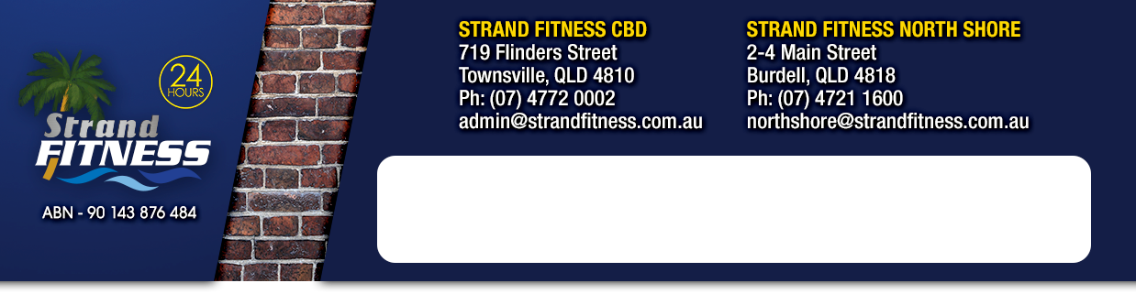

How Can We Help You?

**FIRST NAME: _______________________________ LAST NAME: ________________________________ D.O.B. _______________________**

**PHONE: _____________________________ EMAIL ADDRESS: _________________________________________________________________**

**ADDRESS: ____________________________________________________________________________________________________________**

**_________________________________________________________________________________ POSTCODE: ______________**

Firstly, can I ask is there any medical conditions or injuries we should be aware of?

|  |  |  |  |  |
| --- | --- | --- | --- | --- |
| Heart Condition | Y/N | Diabetes IDDM | Y/N | If Yes, Please Explain: |
| Diabetes NIDDM | Y/N | Back Pain | Y/N |  |
| Joint Problems | Y/N | Asthma | Y/N |  |
| Stroke | Y/N | High/Low Blood Pressure | Y/N |  |
| Chest Pain | Y/N | High Cholesterol | Y/N |  |
| Arthritis | Y/N | Epilepsy | Y/N |  |
| Fainting/Dizziness | Y/N | Major Surgery | Y/N |  |

In case of emergency who should we contact? Name:___________________________ Phone: ________________________

Can I ask what brought you here today? _______________________________________________________________________

And how did you hear about us? _____________________________________________________________________________

Have you been a member of a health club or gym before? YES / NO

What type of exercise, training or sport do you enjoy?

|  |  |
| --- | --- |
| O Weights | O Functional Training |
| O Cardio | O Outdoor Training |
| O Group Fitness Classes | O Swimming |
| O Yoga | O Other – Example Sport |
| O Pilates | _________________________________________________________________________________ |

Why do you enjoy these types of exercise? _______________________________________________________________________

Is there anything you don’t particularly enjoy? ____________________________________________________________________

How many times per week would you like to commit to your exercise and/or training plan? 0 1-2 2-3 3-4 4-5 5-7

Tell me from the below, what is the most important to you?

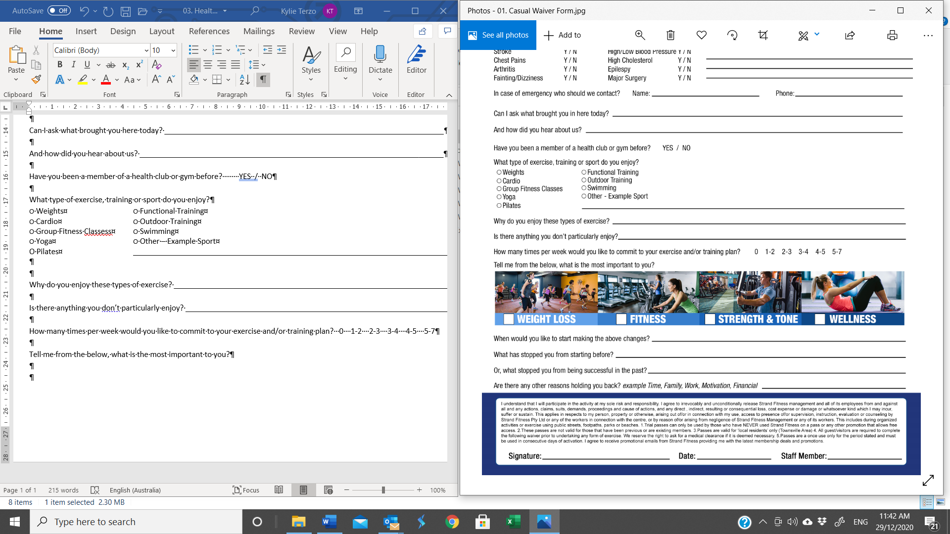

When would you like to start making the above changes? _________________________________________________________

What has stopped you from starting before? ____________________________________________________________________

Or, what stopped you from being successful in the past? __________________________________________________________

Are there any other reasons holding you back? *example Time, Family, Work, Motivation, Financial ________________________*

*I understand that I will participate in the activity at my sole risk and responsibility. I agree to irrevocably and unconditionally release (Insert Name) management and all of its employees from and against all and any actions, claims, suits, demands, proceedings and cause of actions, and any direct, indirect, resulting or consequential loss, cost expense or damage or whatsoever kind which I may incur, suffer or sustain. This applies in respects to my person, property or otherwise, arising out of/or in connection with my use, access to presence of/or supervision, instruction, evaluation or counselling by (Insert Name) or any of the workers in connection with the centre, or by reason of/or arising from negligence of (Insert Name) Management or any of its in connection with the centre, or by reason of/or arising from negligence of (Insert Name) management or any of its workers. This includes during organised activities or exercise using public streets, footpaths, parks or beaches. 1. Trial passes can only be used by those who have NEVER used (Insert Name) on a pass or any other promotion that allows free. 2. These passes are not valid for those that have been previous or are existing members. 3. Passes are valid for ‘local residents’ only (Insert Area). 4. All guest/visitors are required to complete a waiver prior to undertaking any form of exercise. We reserve the right to ask for a medical clearance if it is deemed necessary. 5. Passes are a once use only for the period state and must be used in consecutive days of activation. I agree to receive promotional emails from (Insert Name) providing me with the latest membership deals and promotions.*

*Signature: ____________________ Date: ___ / ___ / ____ Staff Member: ________________*