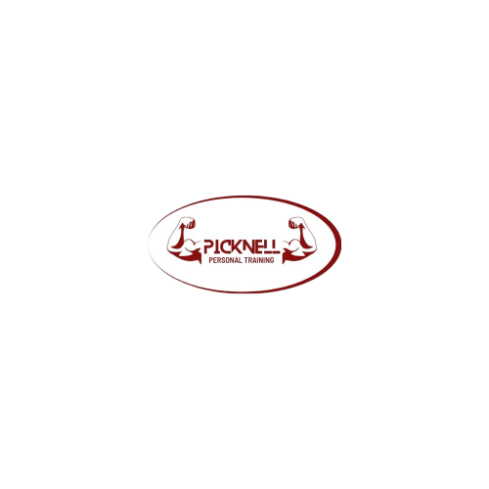Media and Social Media Release

At Picknell Personal Training we like to promote activities, celebrate achievements to share on social media and websites.

We also film educational videos of our programs which are shown in a private non-sharable / downloadable / searchable video format and only available to Picknell Personal Training clients as an example of delivery of fitness related information and services.

Please sign this consent slip to give us permission to publish your and if applicable, your child’s name, image or video in various media.

I ………………….…………………………………. (print name)   
  
and …………………..………………………..…… (insert child name/s if under 18 years)  
   
In signing this form, I grant permission for Picknell Personal Training to use and publish details inclusive of names, event details, outcomes, photographs/images, audio or video footage of myself or my child/ren for promotional purposes on the club’s social media and online channels (websites, Facebook, Instagram,Twitter etc), educational videos, newsletters and occasional main media such as related websites or newspapers.

I understand details, images, video or audio may be seen in a public environment and acknowledge the Picknell Personal Training is not obliged to include my child in any related promotional activities.

Please tick below if you would like to **exclude** any one or more of the above activities:

* Social Media
* Educational Material
* Website
* Main Media

If you have any concerns or questions, please contact Picknell Personal Training.

………………………………………………………. ………………………..

Signed (please include 2 signatures if under 18) Date

……………………………..………….. ………………….…………………………   
Contact Phone Contact Email